Sources
(Lesson to follow on from ‘Stan Harrison’)

The Next Step.
According to students drawn conclusions about the Stan Harrison case, summarise the next step i.e. how will the investigation proceed? Who needs to be questioned, what other evidence is essential?

Overhead
Students copy the first half of the following overhead ‘ Historical Investigation’.

Think Pair Share
Ask students to think about as many source types as they can and independently jot a list under the title ‘Sources’ e.g. books, magazines, encyclopaedias, journals, internet, DVDs, interviews, diaries, paintings, photographs, posters, cartons, maps, graphs, tables, official letters, private letters, clothing, tools, instruments.

Students share their list with a partner.
Ask each pair for a contribution and list on the board
Explain the greater the range of the sources, the stronger the argument becomes for your version of history.

What is a Source?
Students copy the second part of the overhead.

Analysing a visual source
Distribute ‘How sources should be analysed’
Read through as students follow the text.

Distribute ‘Destroy this mad brute’
Place larger overhead onto the white board and annotate and draw reference lines to each section of the image for the students to copy onto their sheets as you add information i.e.
- Poster use for enlistment into the US Army
- Germany likened to a beast
- Dribbling to add distaste
- Moustache to relate characteristics to the Kaiser
- German helmet reinforces connection between beast and nation
- Militarism reinforces the nature of Germany and its intent to American soil
- Club enhances aggression
- Lady possibly depicts ‘Liberty’ – encourages male instinct to defend

Students glue the sheet into their booklets.
Students address each of the source questions in relation to the ‘Mad Brute’ source into their files.

On their own
Distribute German propaganda Poster.
(On ground level, you see a soldier, presumably German, cheering up at the sight of the two other figures. Mounted on horse is the Emperor (or "Kaiser") Wilhelm II, who reigned as the "strong man" in Germany. As in all images of him, the Kaiser concealed his left hand, which was damaged due a birth defect. Protecting the emperor with her shield is a very masculine, slightly scary depiction of Germania, the female national personification of Germany. Such personifications were apparently all the rage at the time, Britain had their Britannia, France had Marianne and the United States had both Lady Liberty and Colombia).
Students cut out one of the images (sets of four) and glue onto a page in their booklet; annotate the image on their own in a similar form to before and then answer the source questions in relation to this image).

As a Group
Ask individual students to contribute an idea from their German poster to be added to an overhead of the image displayed upon the white board.

Discuss with student the differing perspectives in relation to the same historical event and the use of bias within propaganda.

Doc Study
Provide students with a past source from a Doc Study and discuss the nature of the first standard question or two.
Students attempt their answers – collect and assess.

Historical Investigation - Source Work

Historians are like detectives – they begin with a mystery and set out to solve it.

Step One: Define the mystery.
– What needs solving?

Step Two: Create a list of essential questions to be answered.
– These will drive your investigation.

Step Three: Access information that may answer those questions.
- The information accessed is called a ‘Source’.
- Sources that help to answer your questions and solve the mystery become ‘Evidence’

A Source is information about the past.

Evidence is a source that is used to support an historical claim or argument.

A Primary Source is a source made at the time of the historical period e.g. an axe or cooking implement, a letter or diary.

A Secondary Source is a source developed from primary sources; therefore created after the historical period e.g. a book about axes or about a particular person based on diary entries and or letters.

How should sources be analysed?

Who? Who made the sources?

What? What is the content of the source?

When? When was it made or published?

Where? Where was the source made or published?

Why? Why was it made? For whom?

Perspective? What point of view? How does this affect bias/ reliability?

Answers to these questions are necessary for deciding the value of the sources.
All sources are limited in the information they provide and may be biased or ill informed.

Propaganda posters are a good example of historical sources. They are deliberately produced for publication. Their purpose is to elicit a predetermined response in the viewer. The artist often uses techniques such as exaggeration, emotional language and imagery in order to create this response. The viewer also needs to be familiar with the people and/or events being artistically represented.

Propaganda posters may not necessarily be accurate, but as a source for an historian, they are extremely useful in showing attitudes held by people at the time and the tactics employed by people in authority as they tried to manipulate those attitudes.

Questions to ask are:
Who produced the poster?
When did this poster appear?
Where was the poster displayed?
What is the purpose of the poster?
What events were occurring at the time this poster appeared?
What extra knowledge is required in order to understand this poster?
What judgements is the poster making? Is there any bias being displayed in the poster

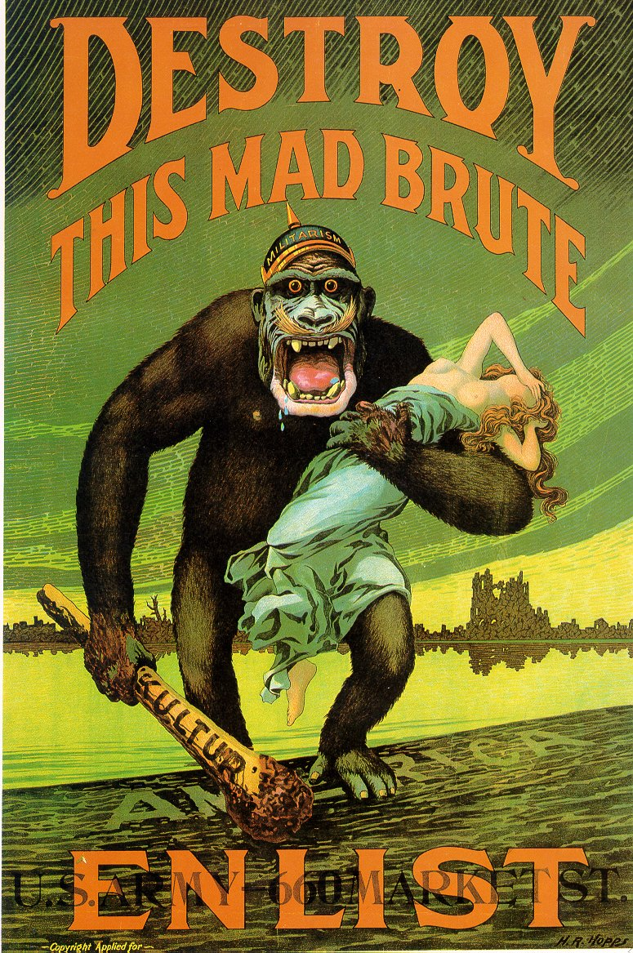
US Army Propaganda Poster: Nationalism Dated 1917

US Army Propaganda Poster: Nationalism Dated 1917

